Bethany Church of Lexington Pastoral Vacancy Announcement
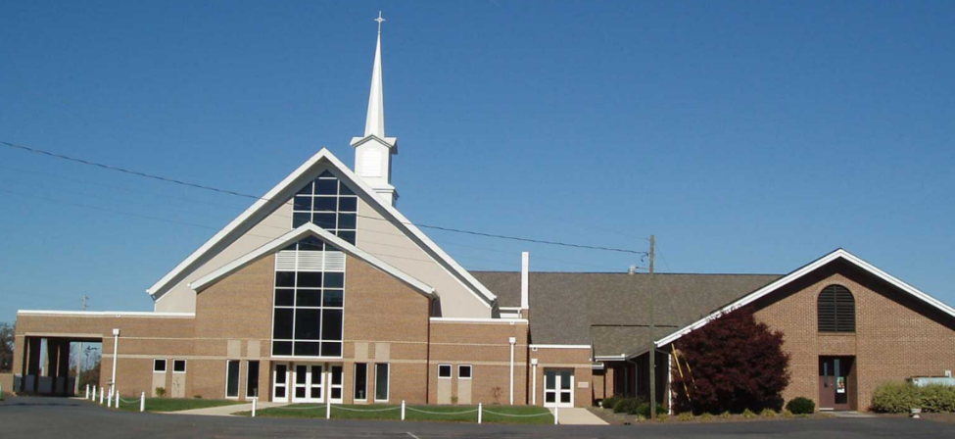
Bethany Church of Lexington is located in central Davidson County, NC. Since our beginning in 1905 as Bethany Methodist Church, we have remained committed to spreading the gospel of Jesus Christ. Our mission is to offer ourselves as a community of faith in service and love in the name of Jesus Christ. We are in covenant with God and our community, empowered by the Holy Spirit, to care for one another and to share ministry with the rest of the world.
Qualifications:
- Bachelor’s Degree required; Master of Divinity from an accredited educational institution or seminary (preferred); candidate for a Master of Arts in related theological fields considered.
- Previous training or interest in receiving training in the Methodist/Wesleyan theology/doctrine
- Licensed/ordained minister preferred; candidate for licensure considered
- Significant related ministerial experience desired (including but not limited to field education, youth and senior adult leadership activities, VBS, worship leader, teacher, lay speaker, missions, counseling)
- Proficient oral and written communication skills
- Effective interpersonal skills including efficacy in conflict resolution
- Ability to prepare and deliver engaging and inspirational Biblically based sermons
Responsibilities:
- Exhibit an impeccable personal integrity and a passionate dedication to God
- Preach and teach the word of God and the gospel of Jesus Christ (weekly sermons, periodic Bible studies, etc.)
- Build relationships with the congregation to serve the needs of individual members and families
- Provide leadership in the development and implementation of the church’s vision and mission
(including the growth of church/Sunday School attendance and the strengthening of children/youth/young adult programming)
- Embody openness toward innovative ideas and initiatives (including worship services, music, and ministries)
- Collaborate with church leadership to effectively manage programs and resources
- Provide loving pastoral care (including but not limited to officiating weddings and funerals, short term counseling, and visitation of sick/hospitalized/homebound)
- Lead in administration of the church’s holy ordinances and sacraments such as baptism and Holy Communion
- Support and attend church events and activities
- Establish a presence in the community by participating in outreach programs and projects (attending school functions, volunteering, coordinating missions)
- Emphasize spiritual growth and development by encouraging all members to develop talents, gifts, and leadership skills in the service of Christ and for the glory of God.
Salary:

Salary is commensurate with experience. (Salary Range: $60,000—$80,000 plus Housing
Allowance) Additional benefits include health insurance and retirement.

Submissions:
All applicants must provide the following information:
- Letter of interest (include how you became a believer in Jesus Christ; why you are called to ministry as a pastor, and why you are interested in coming to Bethany.)
- Resume detailing qualifications and experiences
- Collegiate transcripts
- Copy of ministerial license and/or copy of ordination certificate if completed
- Sample of a recent sermon/message (DVD, CD, YouTube video, written transcript)
- Four letters of recommendation (2 clergy, 1 layperson, 1 collegiate professor or mentor) Each recommendation needs to be in a sealed envelope with the provider’s signature across the sealed envelope flap.
Submit the complete candidate package by mail to:

SPPRC Chairperson
Bethany Church of Lexington
193 Bethany Road
Lexington, NC 27292

Additional Important Information:

- Candidate packages must be postmarked by May 11, 2024.
- Finalist candidates must consent to reference checks, education/credential verification, criminal history background check, substance abuse history check, and credit/financial history review. Additional information may be requested.

All information will be treated as confidential.

